Criteria Tool for Entering Into a Shared Service Arrangement
Multi-jurisdictional shared service arrangements typically move through several phases as described in the Center for Sharing Public Health Services (CSPHS) framework, A Roadmap to Develop Cross-Jurisdictional Sharing Initiatives. The CSPHS framework includes the three process phases that cross-jurisdictional sharing arrangements typically move through: 1) Explore, 2) Prepare and Plan, and 3) Implement and Improve.
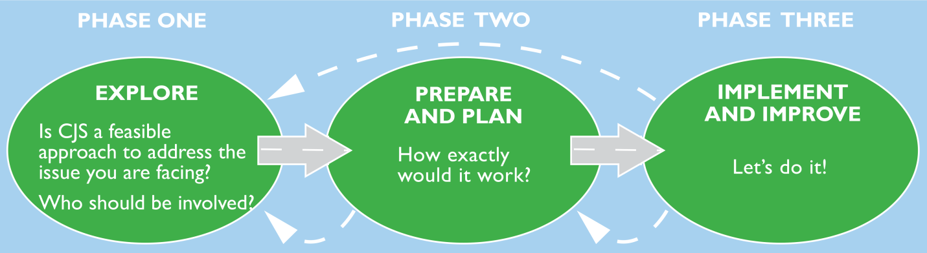
Source: A Roadmap to Develop Cross-Jurisdictional Sharing Initiatives. Center for Sharing Public Health Services (CSPHS) framework, 2013.

This criteria tool was developed to help guide decision-making around entering into shared services arrangements in the Explore phase. The tool helps guide choices around key areas of success in shared service agreements including: goals and expectations, scope of the agreement, partners and stakeholders, fiscal implications, leadership and personnel.

Criteria Development
The development of criteria was informed by a literature review on shared services in government and public health, the CSPHS framework, health officer interviews held from June – August 2013 and board of health discussion groups held from September 2013 – February 2014 in the Northwoods Shared Services Project area.

Using the Tool
The tool is specific to public health and may be used by public health officers, health department staff and their policy board members.
A group of health officers could use the tool as an abbreviated planning checklist in the exploration and feasibility of a potential cross-jurisdictional sharing arrangement.
Health officers interested in entering into a multi-jurisdictional sharing arrangement could use the completed tool to review a potential arrangement with their respective policy board.
Once a decision has been made to move forward with a cross-jurisdictional sharing arrangement, additional tools are available to plan, implement and evaluate the shared service.

Criteria Tool for Phase One: Explore
Goals and expectations:  Why would you consider CJS? | Criteria | Decision
 | Is the initiative in alignment with our mission and core values? | YES NO  Comments:
 | Is the proposed program or service evidence based, and when applicable, designed to improve population health? | YES NO  Comments:
 | Will the shared service help us accomplish at least one of the following:  - achieve an essential public health service  - advance initiatives in a priority area in our community health plan  - enhance the quality of the existing service  - help us provide a mandated service  - improve capacity for achieving public health accreditation? | YES NO  Comments:
Scope of the agreement | Does the proposed agreement assure adequate service levels for the investment of resources for our agency? | YES NO  Comments:
 | Is the proposed agreement clear about which services will be shared and NOT shared, including:  - Functions (e.g. billing, human resources, information technology)  - Programs and Capacity (e.g. WIC, environmental health, epidemiology, lab)? | YES NO  Comments:
Partners and stakeholders | Do the parties in the agreement have experience working together in other CJS agreements, trust each other and have an understanding of the culture and history of each jurisdiction? | YES NO  Previous lessons learned:
 | Is there adequate support for the CJS from policymakers, constituents, clients, and other stakeholders who may be affected by it? | YES NO UNSURE  Comments:
 | Are the proposed outcomes, service model and delivery, and staffing model feasible and supported by the partners, stakeholders and others affected by the CJS initiative? | YES NO UNSURE  Comments:
 | Are the partners in agreement on their respective roles and responsibilities and are they willing to enter into a written agreement? | YES NO  Comments:

Fiscal & Service Implications | Is there a fiscal or service benefit such as:  - New services for less money than could be achieved by doing it alone  - Enhanced quality of service for an affordable investment  - Savings through avoiding capital costs over the medium and long term (3-10 years)  - Reduced annual rates of increase in expenditures  - Decreased annual operating cost  - No increase in annual operating costs  - Lower than expected rate of increase in annual operating costs?  (See Comparison Tool for Fiscal-Service-Staff for greater detail) | YES NO  Comments:
 | Is funding adequate to support staff and resources needed to meet program/service outcomes? Do funds pay for the increased indirect costs to the lead agency? | YES NO  Comments:
 | Is funding at least 2 - 5 years versus one-time, one year funding that is unlikely to be sustainable? Is there a plan for sustainable funding? | YES NO  Comments:
Leadership | Does the lead agency have experience managing CJS arrangements and the appropriate infrastructure in place for all reporting requirements? (See Fiscal Lead Tool for more specific criteria on being a fiscal lead.) | YES NO  Comments:
Personnel | Can we recruit staff from the area workforce with the desired expertise in the location(s) needed? | YES NO  Comments:

