Planning Checklist – Phase Two: Prepare and Plan
This planning checklist for the Prepare and Plan phase was developed using the Center for Sharing Public Health Services (CSPHS) framework, A Roadmap to Develop Cross-Jurisdictional Sharing Initiatives. This framework includes the three process phases that cross-jurisdictional sharing arrangements typically move through: 1) Explore, 2) Prepare and Plan, and 3) Implement and Improve.
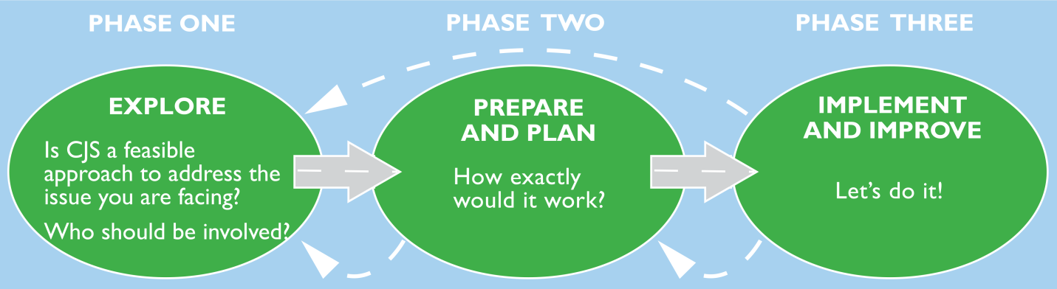
Source: A Roadmap to Develop Cross-Jurisdictional Sharing Initiatives. Center for Sharing Public Health Services (CSPHS) framework, 2013.

References Used
The development of the planning checklist was informed by a literature review on shared services in government and public health, the CSPHS framework, health officer interviews held from June – August 2013, and board of health discussion groups held from September 2013 – February 2014 in the Northwoods Shared Services Project area.

Using the Checklist
Once a decision has been made to move forward with a cross-jurisdictional sharing arrangement, the Prepare and Plan checklist could be used to develop the shared service. The checklist systematically guides the partners through context and history, governance or organizational structure, fiscal and service implications, agreements, legal issues, logistics, communications, change management, timelines, and monitoring.
This tool could be used by health officers, staff and stakeholders in the Prepare and Plan phase but could also be adapted or abbreviated to report to policymakers on the progress of the planning for a cross-jurisdictional sharing arrangement.

Planning Checklist for Phase Two: Prepare and Plan

Products: Implementation assessment and plan, evaluation plan, formal agreement
Context and history | CRITERIA | DECISION
 | An analysis of possible strengths-weaknesses-opportunities-threats (SWOT) to consider in the development of the new initiative’s action plan has been conducted by the key partners. | YES NO  Comments:
 | The key partners have considered lessons learned from past CJS initiatives. | YES NO  Comments:
 | The service delivery model respects the cultural uniqueness of each county/tribe and is adaptable based on local needs if possible. | YES NO  Comments:
Governance | The governance structure will have clear roles and responsibilities of each member, including the lead agency/fiscal agent. | YES NO NOT APPLICABLE  Comments:
 | The governance structure clearly articulates member decision-making responsibilities for goals, objectives, data collection, budget, and future planning. | YES NO NOT APPLICABLE  Comments:
 | The governance structure sets up conditions for continually improving communications, relationships and outcomes. | YES NO NOT APPLICABLE  Comments:
 | The organizational structure is adequate to assure proper management of the CJS. | YES NO  Comments:
 | Conflict resolution is addressed in the governance structure or agreement. | YES NO  Comments:
 | The oversight committee has the knowledge to evaluate if services are happening as proposed or planned. | YES NO NOT APPLICABLE  Comments:

Fiscal and service implications | The proposed service model strives for increased efﬁciency and effectiveness. | YES NO NOT APPLICABLE  Comments:
 | The sharing arrangement increases health department capacity to meet national accreditation standards or is neutral. | YES NO  Comments:
 | There are existing and potential funding streams that can assure adequate and sustainable operational funding beyond 1 – 2 years. | YES NO  Comments:
 | The implementation plan assures a service level that meets or exceeds current levels of performance. | YES NO NOT APPLICABLE IF NEW  Comments:
 | The implementation plan assures a quality of service that is satisfactory for expectations of our jurisdiction. | YES NO  Comments:
 | Flexibility is honored for services that need to be tailored to each jurisdiction. | YES NO  Comments:
Legal sharing agreement | The type of agreement is acceptable (Informal, contract for service, MOU, Mutual Aid Agreement, Other). | YES NO  Comments:
 | The agreement articulates who will have the authority to make decisions. | YES NO NOT APPLICABLE  Comments:
 | The agreement is clear about who will have the authority for staffing decisions. | YES NO NOT APPLICABLE  Comments:
 | The agreement articulates who will have the authority to allocate resources. | YES NO NOT APPLICABLE  Comments:
 | The agreement is clear about how and when a partner can opt out of the agreement. | YES NO NOT APPLICABLE  Comments:

Legal sharing agreement, continued | The agreement articulates the financial commitment of each partner. | YES NO NOT APPLICABLE  Comments:
 | The agreement, if needed, has gone through appropriate committees and boards. | YES NO NOT APPLICABLE  Comments:
 | Policies and procedures specific to the shared arrangement have been developed and approved by the members. | YES NO NOT APPLICABLE  Comments:
Legal issues | Issues related to personnel and vendor contracts (e.g., beneﬁts, collective bargaining agreements, procurement processes, travel policies, residency requirements, information sharing, etc.) have been worked out. | YES NO  Comments:
 | Liability and insurance issues have been addressed. | YES NO  Comments:
 | Corporation Counsels, as needed, have been consulted. | YES NO  Comments:
Logistical issues | The agreement addresses buildings, ofﬁce space, transportation, other properties and other logistical issues. | YES NO  Comments:
 | Adequate facilities to house all personnel, equipment and programs within reasonable geographical proximity to the customers for the shared services have been secured. | YES NO  Comments:
 | Recruitment of staff with the desired expertise in the location(s) needed is progressing as planned. | YES NO  Comments:
Strategic communications  pPlan | External audiences with whom the partners should communicate have been identified. | YES NO  Comments:
 | The messages, messengers and communication methods have been articulated. | YES NO  Comments:

Change mgmt. | A change management strategy has been developed for major shared service projects, especially those that impact management oversight, staffing and services. | YES NO  Comments:
Timeline | A timeline that includes speciﬁc steps to assure success of the sharing initiative has been developed and approved by the key partners. | YES NO  Comments:
Monitoring | An evaluation plan to measure success and effectiveness has been developed and approved by the key partners. | YES NO  Comments:
 | Members agree upon the metrics to be used to evaluate progress. | YES NO  Comments:
 | Data collection methods have been identified and implemented to assure the completion of the evaluation plan. | YES NO  Comments:
Adapted from A Roadmap to Develop Cross-Jurisdictional Sharing Initiatives, Center for Sharing Public Health Services, 2013.

