Planning Checklist – Phase Three: Implement and Improve
The Implement and Improve phase of the planning checklist was developed using the Center for Sharing Public Health Services (CSPHS) framework, A Roadmap to Develop Cross-Jurisdictional Sharing Initiatives. This framework includes the three process phases that cross-jurisdictional sharing arrangements typically move through: 1) Explore, 2) Prepare and Plan, and 3) Implement and Improve.
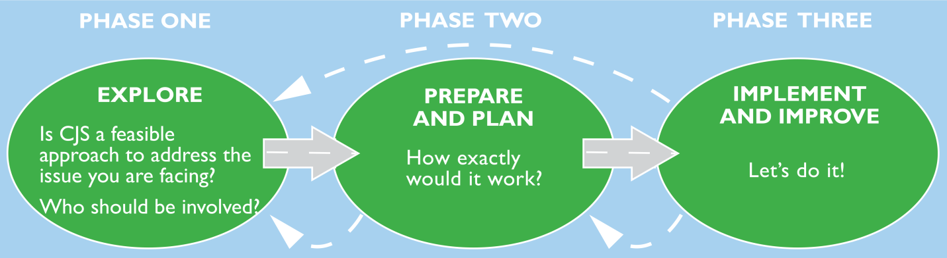
Source: A Roadmap to Develop Cross-Jurisdictional Sharing Initiatives. Center for Sharing Public Health Services (CSPHS) framework, 2013.

References Used
The development of the planning checklist was informed by a literature review on shared services in government and public health, the CSPHS framework, health officer interviews held from June – August 2013 and Board of Health discussion groups held from September 2013 – February 2014 in the Northwoods Shared Services Project area.

Using the Checklist
The criteria in the Implement and Improve phase checklist could be reviewed quarterly, semi-annually or annually to monitor and improve the shared service. The project manager and key stakeholders (health officers) could use the checklist to assess where adjustments to services and activities are needed.
The tool could be used in its entirety or in an adapted or shorter version to report to policymakers on the implementation and outcomes of the cross-jurisdictional sharing arrangement.

Planning Checklist - Phase Three: Implement and Improve

Products: Progress reports, evaluation reports, data on service levels, plan revisions
 | CRITERIA | DECISION
Implementation and  management | The standards and activities are being implemented as planned. | YES NO  Comments:
 | A project management team is in place and meeting expectations as outlined in the scope of the project. | YES NO  Comments:
 | Senior-level support for the CJS has been secured. | YES NO  Comments:
Communications and change management | A change management plan has been implemented and revised as needed. | YES NO NOT APPLICABLE  Comments:
 | A strategic communications plan has been implemented and revised as needed. | YES NO NOT APPLICABLE  Comments:
 | Communications among the partners in the arrangement are satisfactory based on objective feedback (e.g. survey of partners). | YES NO  Comments:
Monitoring and improving | The stated outcomes are being achieved. | YES NO  Comments:
 | A survey of the stakeholders in the agreement demonstrates satisfactory results in communication, goals, activities and service levels. | YES NO  Comments:
 | Stakeholders in the arrangement have indicated and discussed revisions that they would like to see implemented in the next year. | YES NO  Comments:
 | The implementation plan has been reviewed, updated and agreed upon by the members, including MOUs, contracts, etc. | YES NO  Comments:
 | An annual work plan has been developed, reviewed and agreed upon by the members. | YES NO  Comments:
 | Knowledge acquired by the shared service has been shared with the project team and other stakeholders. | YES NO  Comments:
Adapted from A Roadmap to Develop Cross-Jurisdictional Sharing Initiatives, Center for Sharing Public Health Services, 2013.

